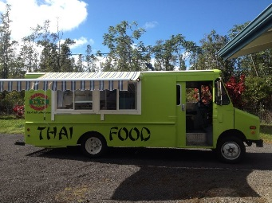
TUK TUK THAI FOOD, Volcano Hawaii

(808)747-3041
www.tuk-tukthaifood.com
TUESDAY-SATURDAY: 11:00AM-6:00PM
(Tofu $10.00, Chicken $11.00, Shrimp $13.00) **
#1 PAD THAI NOODLE The most famous Thai noodle dish, rice noodles pan fried with egg, your choice of meat/ tofu with mixed vegetable , stir fried with pad thai sauce, topped with scallions, carrots, cabbage , lemon and ground peanuts.
#2 CRAZY NOODLE Stir fried wide rice noodle with egg, choice of your meat/tofu mixed vegetables, basil and house special chili sauce.
#3 FRIED RICE (white or brown rice) This delicious fried rice is stir fried with egg and your choice of meat or tofu as well as mixed vegetables.
#4 PINEAPPLE CURRY (served with white or brown rice) Choice of chicken, shrimp or tofu simmered in curry sauce, coconut milk with pineapple, celery, carrots and basil leaves.
#5 MASSAMAN CURRY (served with white or brown rice) Choice of chicken, shrimp or tofu in massaman curry, coconut milk, onion, steamed carrots and potatoes.
#6 STIR FRIED CASHEW NUT (served with white or brown rice) Stir fried mixed vegetables with your choice of meat and cashew nuts.
# 7 STIR FRIED BASIL (served with white or brown rice) Stir fried mixed vegetables, bamboo shoots with your choice of meat and basil.
#8 TOM YUM SOUP (SPICY AND SOUR SOUP) The most famous Thai hot and sour soup spiced with vegetable, lemongrass, galanga, kaffir lime leaves, lemon juice, tomatoes, chili and mushrooms.
#9 TOM KHA SOUP (COCONUT SOUP) Thai style coconut soup seasoned with vegetable, carrots, galanga, tomatoes, lemon juice, lemongrass and kaffir lime leaves
#10 FRIED SPRING ROLL $7.00 Popular crispy spring rolls with vermicelli noodle, vegetables, yellow bean and sweet potato served with pineapple sauce.
**consuming raw or under-cooked meat can be harmful to your health

#11 FRESH AVOCADO SUMMER ROLL $8.00 Fresh avocado, green leaf lettuce, basil leaves, alfalfa sprouts, wrapped with fresh rice paper, served with pineapple sauce or peanut sauce.
#12 GREEN PAPAYA SALAD $8.00 (add avocado $9.00) The green papaya combines wonderfully with lemon juice, tomato, string bean, carrot and ground peanuts with a house special sauce.
#13 RED CURRY (served with white or brown rice) Choice of chicken, shrimp or tofu simmered in red curry sauce, coconut milk with mixed vegetables, bamboo shoot and basil leaves.
#14 AVOCADO CURRY (served with white or brown rice ) Choice of chicken, shrimp or tofu simmered in a green curry, coconut milk, chunks of avocado with mixed vegetables.
#15 STIR FRIED EGGPLANT (served with white or brown rice) Choice of chicken, shrimp or tofu stir fried with Japanese eggplant, basil and mixed vegetables
#16 SWEET AND SOUR (served with white or brown rice) Choice of chicken, shrimp or tofu stir fried in a sweet chili sauce with pineapple and mixed vegetables.
#17 PAD SE EW NOODLE Stir fried wide rice noodle with egg, choice of chicken, shrimp or tofu, mixed vegetables in a black bean sauce.
#18 PUMPKIN CURRY (served with white or brown rice) Choice of chicken, shrimp or tofu simmered in red curry sauce, coconut milk with pumpkin, mixed vegetables and basil leaves.

**consuming raw or under-cooked meat can be harmful to your health

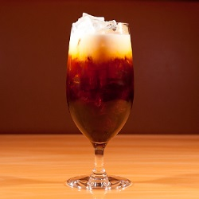 Thai Ice Tea $2.00 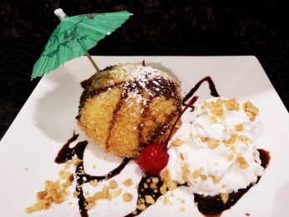 Fried Ice Cream $5.00
Fried Banana Lumpia $1 per piece

MAHALO !!!

